**Github Action**

11.04.2024

**─**

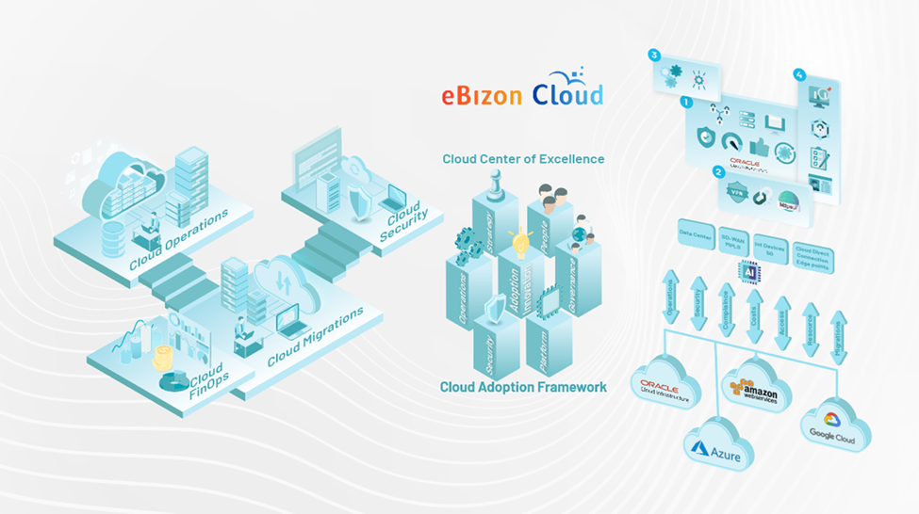

Chandira Sekaran | Ebizoncloud LLC

**Table of Content**

**1.** **Repository Action** 2

**1.1** 2

**2.** **Issue Actions** 3

**1** 3

**3.** **Pull Request Actions** 4

**1.1 list** 4

**4.** **Milestone Actions** 5

**1.1 test** 5

**5.** **User Actions** 5

**6.** **Search and Query Actions** 5

**7.** **Webhook and Event Actions** 5

# **Repository Action**

## **1.1 types**

1. **Create a repository dispatch event**
   * Triggers a repository dispatch event to notify external services or workflows.
2. **Create a repository using a template**
   * Creates a new repository based on a template repository.
3. **Deletes a GitHub Webhook**
   * Removes a webhook previously configured for a repository.
4. **Get a repository by Id**
   * Retrieves a repository's metadata based on its unique ID.
5. **Get a repository public key**
   * Returns the public key used for encrypting secrets for the repository.
6. **Lists all public repositories for an organization**
   * Retrieves a list of public repositories belonging to a specific organization.
7. **Remove selected repository from an organization secret**
   * Removes the repository's access to an organization's encrypted secret.

# **Issue Actions**

## **1.1 types**

**Create an issue**

Creates a new issue in a specified repository.

**Find issues by state and keyword**

Searches for issues in a repository based on their state (open, closed) and keywords.

**Get a particular issue of a repository**

Retrieves the details of a specific issue by its issue number.

**Get all issues of a repository**

Fetches all issues in a repository, including open and closed issues.

**Lists all labels for a repository**

Lists all available labels defined in a repository.

**Lists all labels for an issue**

Retrieves all labels applied to a specific issue.

**Lists the available assignees for issues in a repository**

Shows all users who can be assigned issues in a repository.

.

# **Pull Request Actions**

## **1.1 types**

• **Get a pull request**

* Fetches the details of a specific pull request using its pull request number.

• **Get a reference**

* Retrieves the reference (ref) details of a branch or tag in a repository.

• **Get all Pull Requests of A Repository**

* Returns a list of all pull requests in a repository.

• **Get the list of files from a pull request**

* Lists all the files that were changed, added, or deleted in a specific pull request.

• **Merge a pull request**

* Merges a pull request into its base branch.

• **Request reviewers for a pull request**

* Assigns reviewers to an open pull request

# **Milestone Actions**

## **1.1 types**

• **Lists all milestones of a repository**

* Retrieves all milestones created in a repository.

• **Update a milestone**

* Updates the details (title, description, due date) of a specific milestone.

# **User Actions**

**Get the authenticated user**

* Retrieves the user information for the authenticate

# **Search and Query Actions**

**Search GitHub using Query**

* Allows you to search for repositories, code, issues, pull requests, and more using a custom search query.

# **Webhook and Event Actions**

• **Deletes a GitHub Webhook**

* Removes a webhook for a specific repository to stop event notifications.

• **Create a repository dispatch event**

* Sends an event trigger to external services or GitHub workflow.